## The final model is wt...7 ~ gestation + smoke + ht + drace + parity + dht

##Use the final model to bootstrap to generate the confidence interval of intercept and slope of explanatory variables

#Gestation

#Store the regression coefficients of gestation

#Regression bootstrap coefficients- the empirical sampling distribution for the parameters

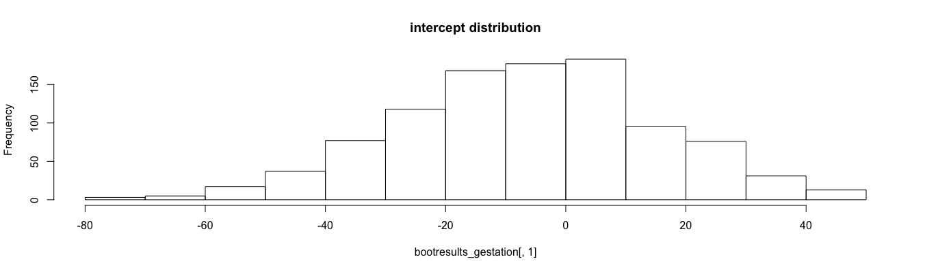

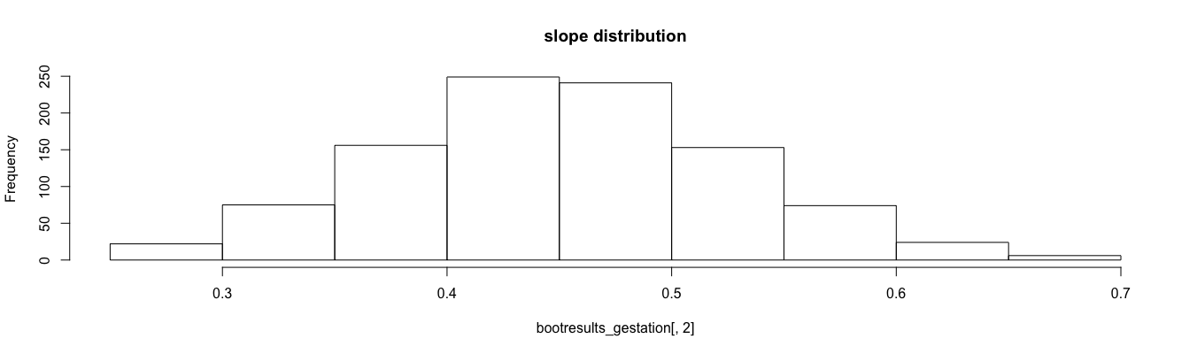

#generate the best guess of parameter

> c(mean(bootresults_gestation[,1]), mean(bootresults_gestation[,2]))

[1] -6.3256492 0.4504879

> #the CIs for these

> rbind(quantile(bootresults_gestation[,1], probs = c(0.025, 0.975)),

+ quantile(bootresults_gestation[,2], probs = c(0.025, 0.975)))

2.5% 97.5%

[1,] -49.5776522 34.1110382

[2,] 0.3067857 0.6058702

*1 is intercept, 2 is slope

#smoke

#store the regression coefficients of smoke

#Regression bootstrap coefficients- the empirical sampling distribution for the parameters

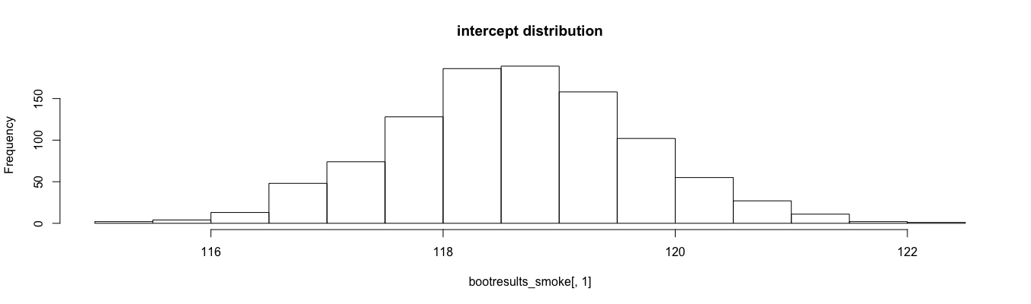

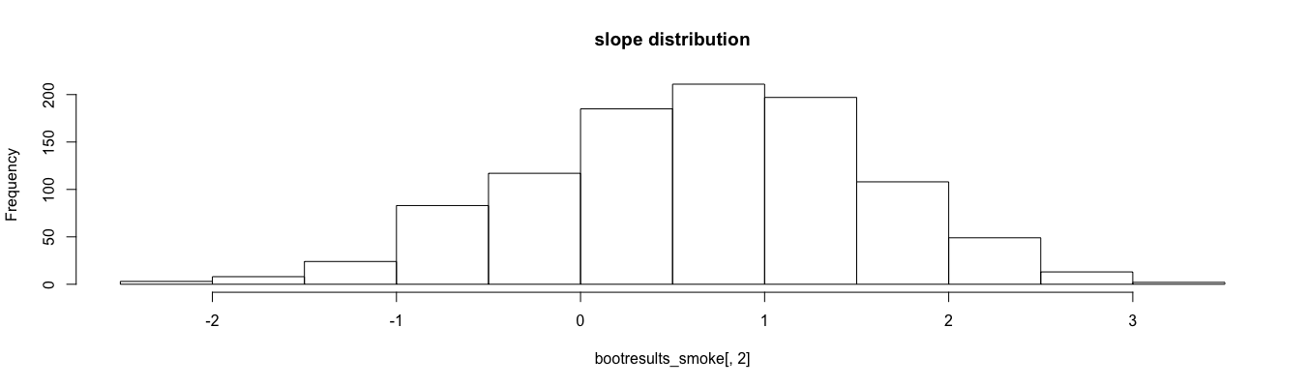

#best guess of paramaters

> c(mean(bootresults_smoke[,1]), mean(bootresults_smoke[,2]))

[1] 118.6342888 0.6539734

# the CIs for these

> rbind(quantile(bootresults_smoke[,1], probs = c(0.025, 0.975)),

+ quantile(bootresults_smoke[,2], probs = c(0.025, 0.975)))

2.5% 97.5%

[1,] 116.578309 120.765400

[2,] -1.253745 2.312133

#ht

#Regression bootstrap coefficients- the empirical sampling distribution for the parameters

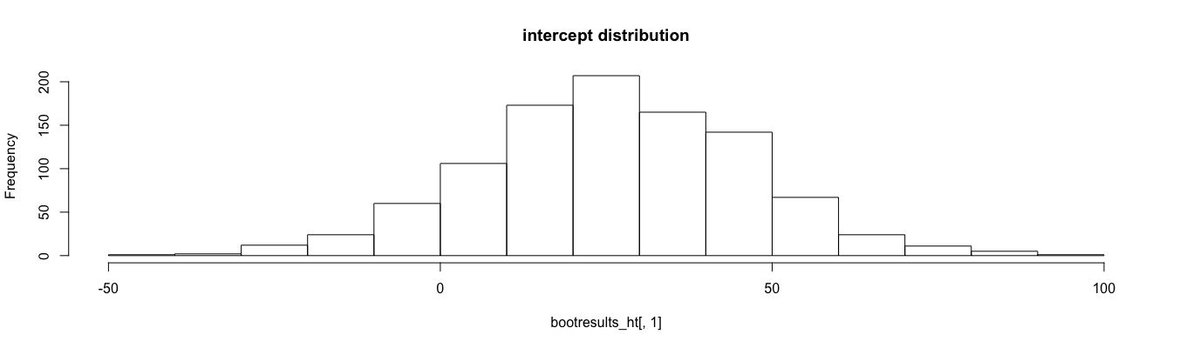

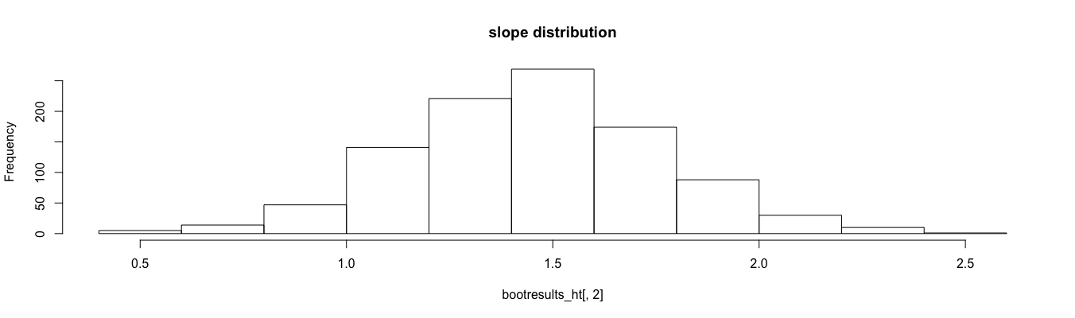

> #generate the best guess of the parameters

> c(mean(bootresults_ht[,1]), mean(bootresults_ht[,2]))

[1] 25.957888 1.453939

> rbind(quantile(bootresults_ht[,1], probs = c(0.025, 0.975)),

+ quantile(bootresults_ht[,2], probs = c(0.025, 0.975)))

2.5% 97.5%

[1,] -13.8631657 64.235084

[2,] 0.8641723 2.074731

#drace

#Regression bootstrap coefficients- the empirical sampling distribution for the parameters

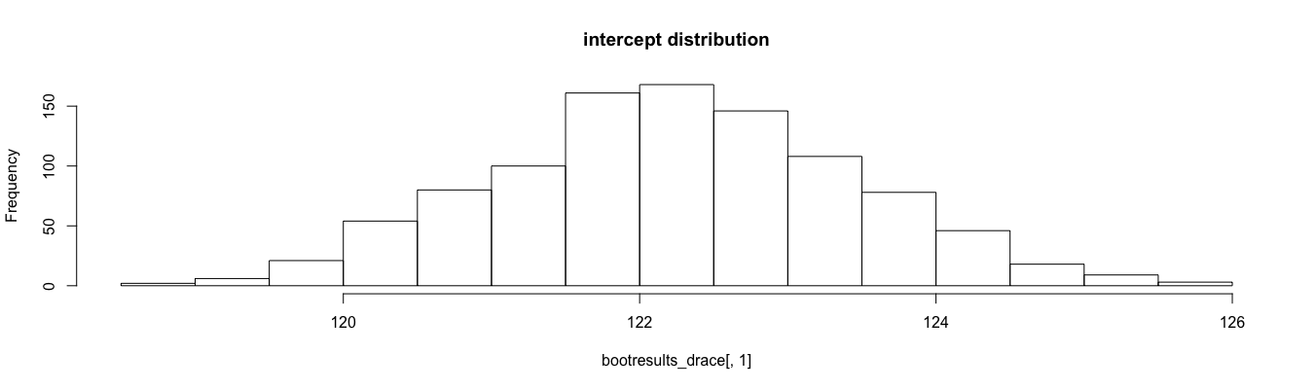

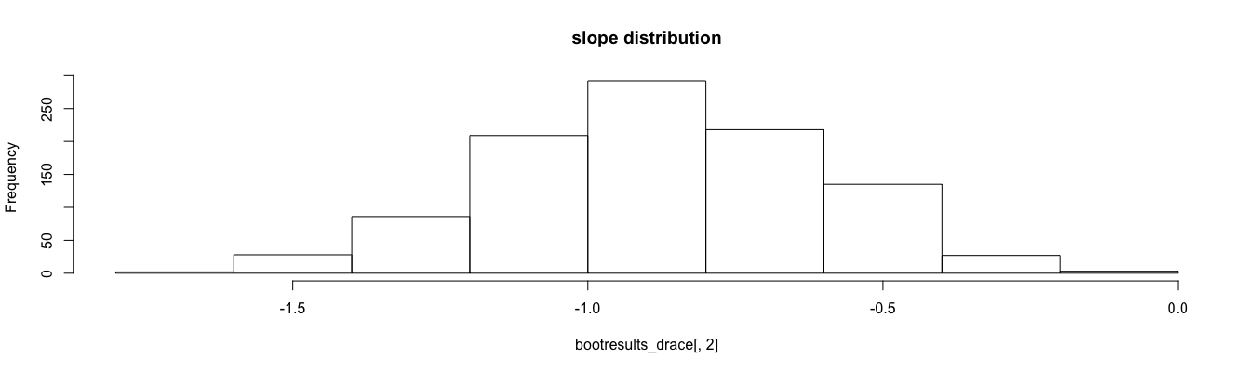

> #generate the best guess of parameters

> c(mean(bootresults_drace [,1]), mean(bootresults_drace [,2]))

[1] 122.2413185 -0.8782847

> # the CIs for these

> rbind(quantile(bootresults_drace [,1], probs = c(0.025, 0.975)),

+ quantile(bootresults_drace [,2], probs = c(0.025, 0.975)))

2.5% 97.5%

[1,] 119.938731 124.53937

[2,] -1.414339 -0.38109

#parity

#Regression bootstrap coefficients- the empirical sampling distribution for the parameters

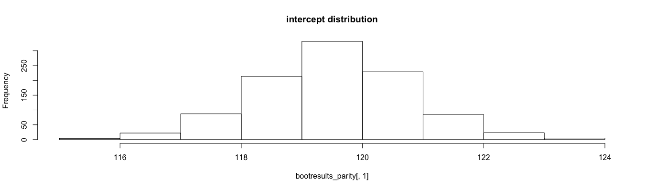

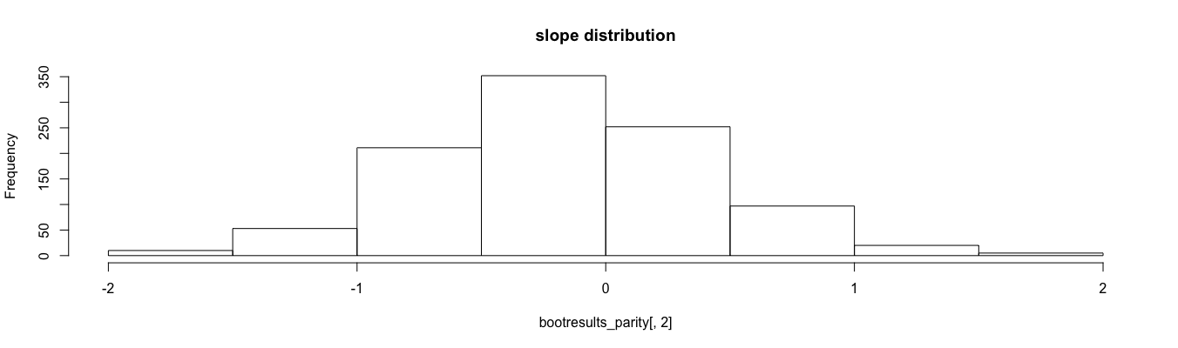

> #generate the best guess of parameters

> c(mean(bootresults_parity [,1]), mean(bootresults_parity [,2]))

[1] 119.5266720 -0.1545513

> # the CIs for these

> rbind(quantile(bootresults_parity [,1], probs = c(0.025, 0.975)),

+ quantile(bootresults_parity [,2], probs = c(0.025, 0.975)))

2.5% 97.5%

[1,] 116.978147 122.0355274

[2,] -1.281422 0.9741778

#dht

#Regression bootstrap coefficients- the empirical sampling distribution for the parameters

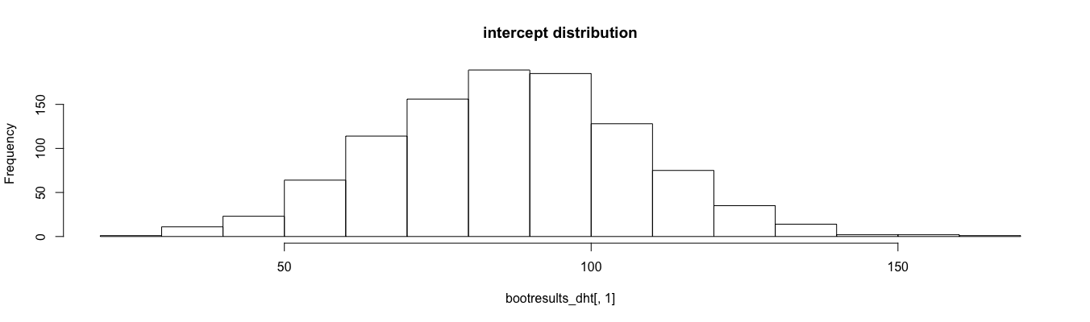

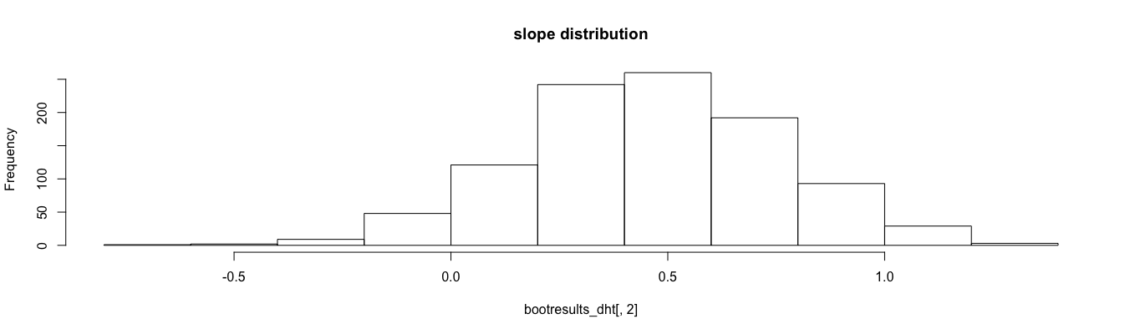

> #generate the best guess of parameters

> c(mean(bootresults_dht [,1]), mean(bootresults_dht [,2]))

[1] 86.9127988 0.4596269

> rbind(quantile(bootresults_dht [,1], probs = c(0.025, 0.975)),

+ quantile(bootresults_dht [,2], probs = c(0.025, 0.975)))

2.5% 97.5%

[1,] 46.1365780 126.754804

[2,] -0.1192279 1.038155

The confidence interval of slope of each explanatory variables indicate whether they have significant effects on response variable, i.e. wt…7